HPPARα as a Candidate Binder of a Mutagenic Benzo[a]pyrene Derivative

Corban Swain September 27, 2017 20.420

# Target Significance

Polycyclic aromatic hydrocarbons (PAHs) are a class of small molecule compounds that are comprised of multiple aromatic rings; these compounds have been shown to have severe carcinogenic effects and are found in a number of sources, including tar, smog, soot, and other products of burning.1 One specific PAH is Benzo[a]pyrene (BP, **1**), which is found in a number of sources including tobacco smoke and, alarmingly, grilled meats.2 BP is classified as a Group 1 carcinogen by the International Agency for Research on Cancer.3 In cells, PAHs derive their carcinogenic activity via a number of mechanisms including cancer initiation by the creation of mutations.4 An oxidized metabolite of BP, (+)-Benzo[a]pyrene-7,8-dihydrodiol-9,10-epoxide (BPDE, **2**), has been suggested to induce mutations by binding to the guanine base in DNA.5 This binding is due in part to the reactive nature of the epoxide ring in the structure, which accepts electron density from one the nitrogen atoms in guanine (and potentially other bases). The binding with and intercalation of BPDE into the DNA double helix leading to an increased susceptibility to incorrect base paring has been proposed to explain BPDE’s mutagenic effects.6

Because of its genotoxic nature I have chosen BPDE as my target for protein binding. By designing a protein that can tightly bind and potentially offer a nucleophile to covalently bond the reactive epoxide, I hope to provide a means to reduce the concentrations of BPDE in situ. Additionally, a strong binder of BPDE could be used as part of a cellular screening system for PAHs from a number of sources.

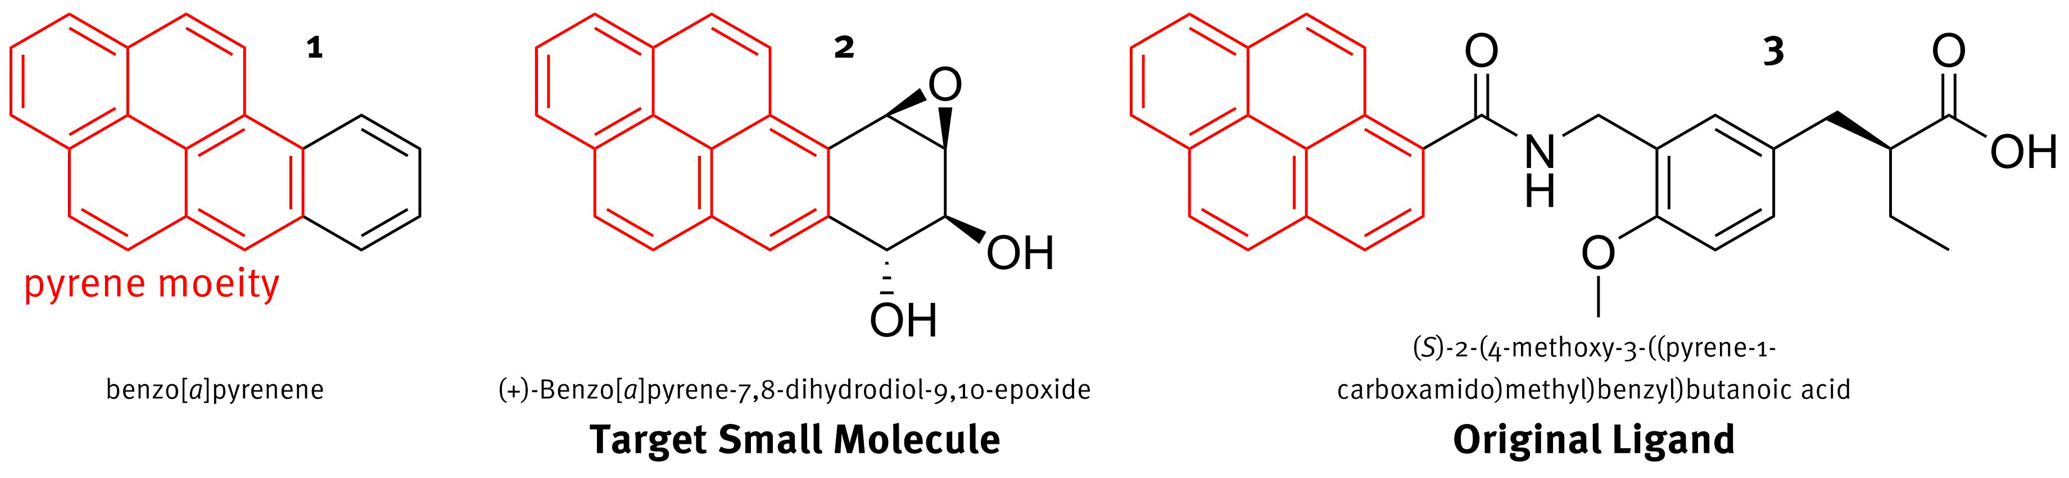

Figure 1. Benzo[a]pyrene, 1, is a member of a class of compounds called polycyclic aromatic hydrocarbons (PAHs); one if its oxidized metabolites, 2, was chosen the target molecule for my protein design because of its toxic, mutagenic effects. The candidate protein has been shown to bind a ligand, 3, with the same tetracyclic pyrene moiety as the target molecule.

# Chosen Protein-Ligand Complex

For a starting point in my protein design, I will use the ligand binding domain of human peroxisome proliferator-activated receptor alpha (HPPARα LBD) complexed with a synthetic agonist, (S)-2-(4-methoxy-3-((pyrene-1-carboxamido)methyl)benzyl)butanoic acid (MPBA, **3**), Figure 2. The PDB reference for this complex is 3VI8. This protein has been successfully expressed in E. coli as demonstrated by Kuwabara et. al. in their reports on various HPPAR crystal structures.7

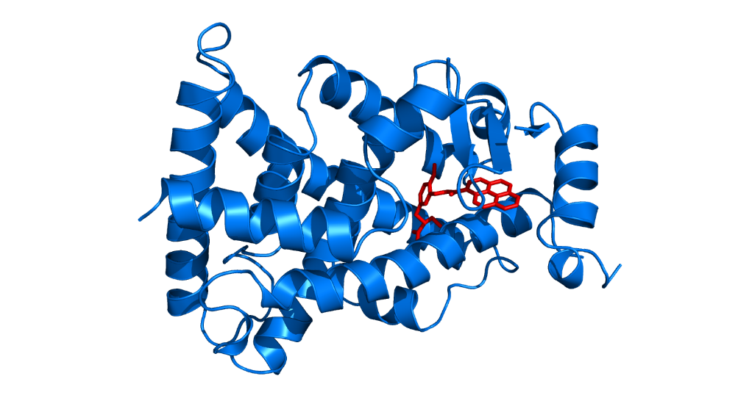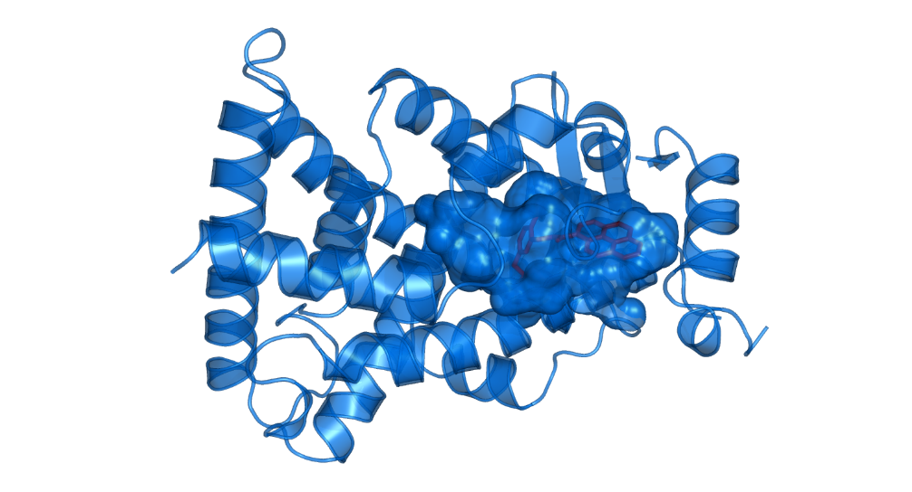

A

B

Figure 2. The known structure for HPPARα LBD shows promise for accommodating our target compound. A: The structure of the HPPARα LBD (blue) in complex with MPBA (red). B: The same structure with the surface of the binding pocket shown (transparent blue). For the protein cartoons, spirals represent α-helices while adjacent arrows represent β-sheets.

I chose this complex because the ligand, MPBA, contains a pyrene moiety, just as is found in the BPDE molecule, Figure 1. The binding pocket for HPPARα LBD shields the hydrophobic pyrene from the surrounding aqueous environment, by placing it in the interior face of the binding pocket. Additionally, the aromatic pyrene seems to be stabilized by surrounding a Phe residue along with a number of non-polar residues including Ile, Leu, Ala, Val, Figure 3B.  The binding pocket offers a number of sites, including Thr-169, Cys-276, and Met-330 that come close to the alcohol and epoxide groups on BPDE and can be altered to interact favorably with those   
heteroatoms.

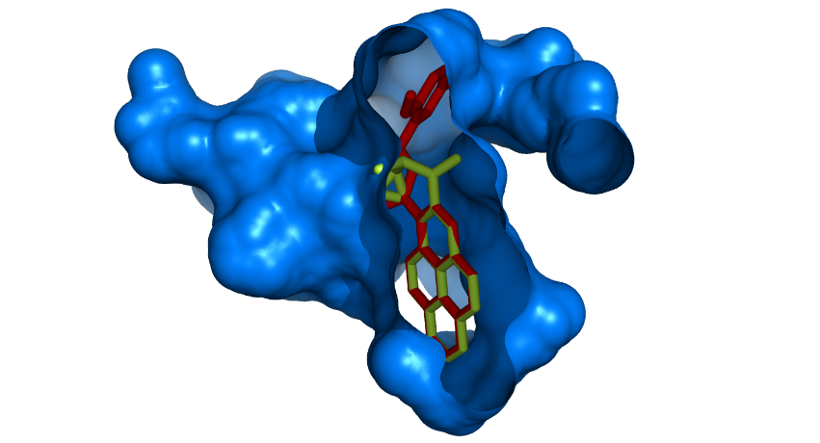 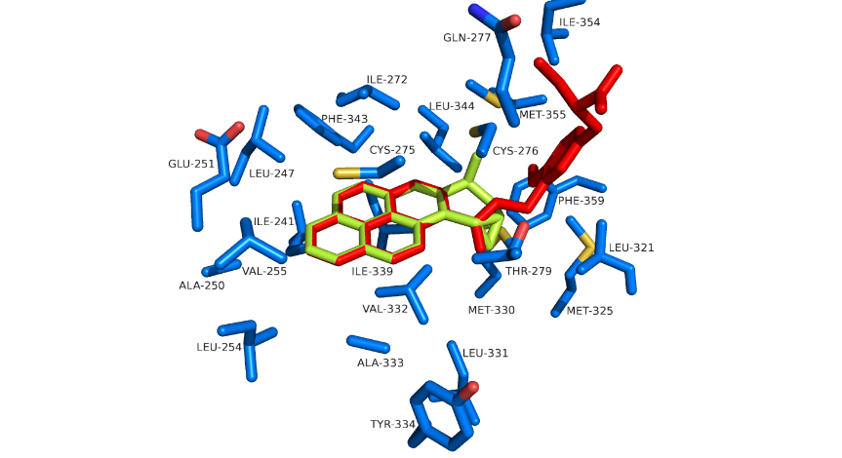

A

B

Figure 3. BPDA was successfully docked into HPPARα LBD by using the location of the original ligand in the complex as a guide. A: A cross section of the HPPARα LBD binding pocket (blue) with both MPBA (red) and BPDE (green) docked in its interior. Note the steric clash where one alcohol of BPDE passes through surface of binding pocket. B: Protein side chains (C: blue, O: red, N: blue, S: yellow) surrounding MPBA and BPDE within the binding pocket.

# References

1. Boström, C.-E.; Gerde, P.; Hanberg, A.; Jernström, B.; Johansson, C.; Kyrklund, T.; Rannug, A.; Törnqvist, M.; Victorin, K.; Westerholm, R., Cancer risk assessment, indicators, and guidelines for polycyclic aromatic hydrocarbons in the ambient air. *Environmental Health Perspectives* **2002,** *110* (Suppl 3), 451-488.

2. Lijinsky, W.; Ross, A. E., Production of carcinogenic polynuclear hydrocarbons in the cooking of food. *Food and Cosmetics Toxicology* **1967,** *5* (Supplement C), 343 - 347.

3. Agents Classified by the IARC Monographs. ClassificationsAlphaOrder.pdf, Ed. International Agency for Research on Cancer: 2017.

4. Baird, W. M. a. H. L. A. a. M. B., Carcinogenic polycyclic aromatic hydrocarbon-DNA adducts and mechanism of action. *Environmental and Molecular Mutagenesis* **2005,** *45* (2-3), 106--114.

5. Karle, I. L.; Yagi, H.; Sayer, J. M.; Jerina, D. M., Crystal and molecular structure of a benzo[a]pyrene 7,8-diol 9,10-epoxide N2-deoxyguanosine adduct: Absolute configuration and conformation. *Proceedings of the National Academy of Sciences of the United States of America* **2004,** *101* (6), 1433-1438.

6. Eisenstadt, E.; Warren, A. J.; Porter, J.; Atkins, D.; Miller, J. H., Carcinogenic epoxides of benzo[a]pyrene and cyclopenta[cd]pyrene induce base substitutions via specific transversions. *Proceedings of the National Academy of Sciences* **1982,** *79* (6), 1945-1949.

7. Kuwabara, N.; Oyama, T.; Tomioka, D.; Ohashi, M.; Yanagisawa, J.; Shimizu, T.; Miyachi, H., Peroxisome Proliferator-Activated Receptors (PPARs) Have Multiple Binding Points That Accommodate Ligands in Various Conformations: Phenylpropanoic Acid-Type PPAR Ligands Bind to PPAR in Different Conformations, Depending on the Subtype. *Journal of Medicinal Chemistry* **2012,** *55* (2), 893-902.